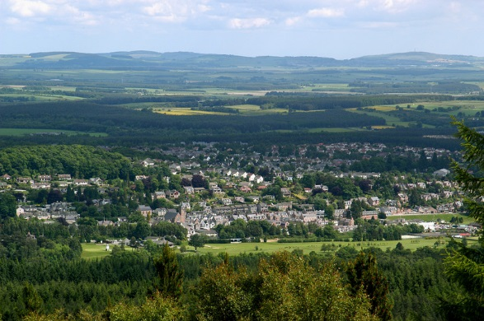

Banchory Signage Strategy: Report of Audit Results and Recommendations for Improvement

8th November 2016

Report prepared by: Andrew Diansangu, Strategy Development Officer and John Aggasild, Strategy Support Officer; Infrastructure Services.

Contents
1. INTRODUCTION 3
2. SCOPE OF WORK AND AIMS 5
3. METHODOLOGY 5
3.1 Data collection 5
3.2 Analysis 9
3.3 Development of Recommendations 10
3.4 Next Steps: Consultation and Project Timeline 11
APPENDICES 13
APPENDIX 1: RECOMMENDATIONS 13
1.1 Proposed Finger Posts Signs (See Drawing AC/BSP/208) 13
1.2 Proposed Vehicular Signs (See Drawing Number AC/BSP/023) 18
1.3 Vehicular Signs to be Removed (See Drawing Number AC/BSP/006) 23
1.4 Vehicular Signs to be Retained (See Drawing Number AC/BSP/006) 24
1.5 General Signage Recommendations 26
1.6 Information & Interpretation Board Recommendations (See Drawing Number AC/BSP/003B) 29
1.7 Street Furniture Recommendations (See Drawing No.s AC/BSP/001, 002,004, 005A and 027) 34
1.8 Recommendations for Materials 36
1.9 Emerging Technologies 36
1.10 Rubbing Posts 37
APPENDIX 2: SUPPLEMENTARY INFORMATION 38
2.1 Asset Guide 38
2.2 Table of Destinations and Number of Signs, July 2016. 45
2.3 Attractions, businesses, organisations without signage at time of data collection, July 2016. 47
APPENDIX 3: Drawings 49
3.1 AC/BSP/001 – Lamp post recommendations 49
3.2 AC/BSP/002 – Bins recommendations 49
3.3 AC/BSP/003b – Information board recommendations 49
3.4 AC/BSP/004a – Benches recommendations 49
3.5 AC/BSP/005a – Street furniture recommendations 49
3.6 AC/BSP/006a – Existing signs 49
3.7 AC/BSP/023 – Proposed vehicular signs 49
3.8 AC/BSP/027 – Planters recommendations 49
3.9 AC/BSP/028 – Fingerposts recommendations 49
3.10 AC/BSP/041 – Scott Skinner Archway & Street Name Plates 49

INTRODUCTION

On 15 June 2016, Aberdeenshire Council’s Transportation Strategy Team were appointed by the Banchory Town Centre Improvement Group (TCIG) as consultants on a signage and street furniture improvement project.
This report details the findings of an audit undertaken to identify the location, condition and suitability of all existing items of signage and street furniture within Banchory. The report then details recommended improvements.
The audit encompassed three elements:
- Signage
- Information Boards
- Town Centre Street Furniture & Streetscape Rationalisation
This report provides recommendations for the town of Banchory as defined by the Local Development Plan (LDP), with the key study area having been the Town Centre as also defined by the LDP. The maps overleaf illustrate the scope of the study area, with the following areas specifically being identified on the maps.
- Town Centre
- Entire Study Area
- Scott Skinner Square
- Falls of Feugh.

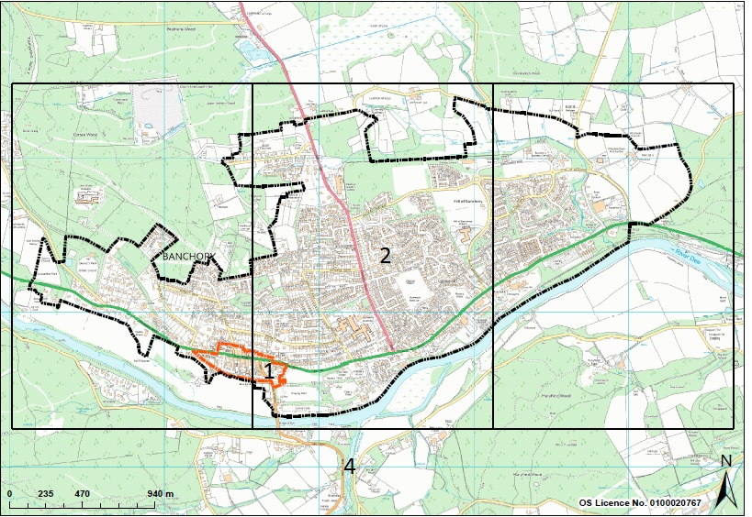
Figure 1 – Banchory Study Area (source LDP)

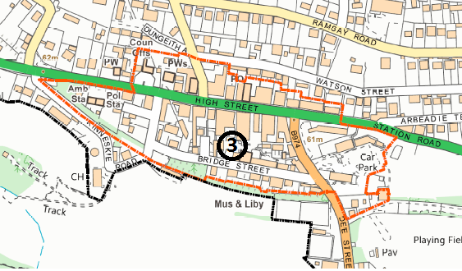
Figure 2 - Banchory Town Centre (source LDP)

2. SCOPE OF WORK AND AIMS

The scope of work and aims of the study are set out below for each of the elements being considered:
Element | Scope and Aims
Signage | Audit of directional/information signage from A93 (East and West) and from other main approaches into Banchory. Recommendations for improvements to encourage visitors to break their journey, highlight attractions in town.
 | Audit of vehicular directional/ information signage within study area. Recommendations for improvements to signpost motorists to visitor attractions and main facilities.
 | Audit of pedestrian, cyclist directional information signage within the study area (including finger posts) with particular reference to main facilities and visitor attractions and recommendations for improvements.
 | Assessment of black metal street name plates with gold lettering in Scott Skinner Square/ Town Centre and recommendations to ensure fit with overall signage strategy.
 | Assessment of Scott Skinner Square archway entrance sign and recommendations from improvement (consideration of retention or alteration to fit in with overall signage strategy and artwork in SSS).
 | Production of detailed designs and specifications for proposed signage within Town Centre and outline designs for signage out with Town Centre.
 | Identification of opportunities for linked public transport information (e.g. buses and park & ride).
Information boards | Audit of all existing information boards in Study Area.
 | Identify inadequacies and omissions in overall coverage and recommendations to address these (including proposed content and location).
 | Identification of appropriate house styles for any proposed interpretation boards and materials to be used.
 | Include community noticeboards in audit (location and state of repair).
Street Furniture | Audit of all street furniture in Town Centre, identifying inadequacies and omissions and recommendations for improvement.

3. METHODOLOGY

The methodology of the study involved the following stages:
- Data collection
- Analysis
- Development of recommendations and designs
- Consultation on proposals.

3.1 Data collection
Data collection was carried out by taking photographs using a GPS equipped camera of all signs, information boards, community noticeboards and street furniture in the study area.
The photos were then transferred onto PC and entered into an ‘asset register’ to record details of asset type and other characteristics. In addition, the ‘asset register’ geographically maps assets based on the embedded co-ordinate data in the photo files.
It is noted that in relation to signs, the recorded number of assets relates to the number of sign plates. In a number of locations, multiple sign plates are installed on the same sign pole(s). In addition, a number of sign poles have sign plates attached on either side so as to provide information for multiple directions of travel e.g. Speed Limits.
A major component of the audit involved identifying and recording the condition of existing signs and street furniture. For the purpose of the audit, a sign was deemed to be defective if it was:
• Illegible (including if obscured by overhanging branches)
• Missing
• Damaged
• Incorrect (e.g. pointing in the wrong direction).
NB. Since undertaking the audit, a ‘scoring matrix’ has been devised by Aberdeenshire Council’s Local Roads teams, which considers the above and additional factors to determine the condition scale of a particular sign. To ensure consistency, all signs identified within the audit will be re-assessed using this new methodology with additional recommendations made as required.
The graphs below illustrate the number and condition of assets recorded during the study by different variables.
Maps in Appendix 3 illustrate the current geographical location of each asset type.
+
Graph 1: Number of signs in Banchory by type.

Graph 2: Number of signs in Banchory Town Centre by type.

Graph 3: Condition of Signs in Banchory

Graph 4: Condition of Signs in Town Centre

Graph 5: Information boards in Banchory by type.

Graph 6: Street Furniture by type in Banchory vs Town Centre

3.2 Analysis

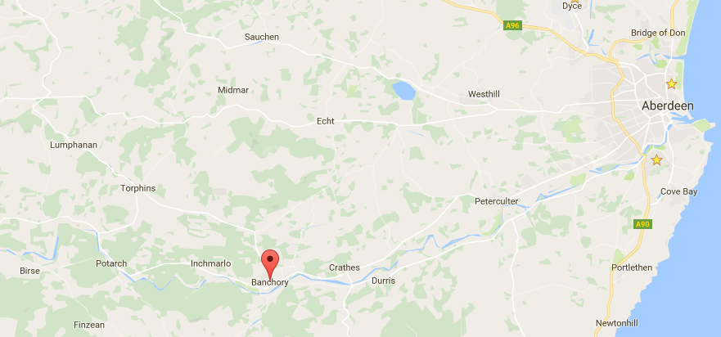
Banchory in Aberdeenshire
Banchory is situated approximately 10 miles west of Aberdeen. As of November 2015 the estimated population for the town was 7,687. There are a number of nearby tourist destinations including Crathes Castle, the Falls of Feugh, the Royal Deeside Railway and Scolty Tower.
Landmarks that aid orientation within the town include the High Street, Dee Street and the bridge/ river.

The main entry points into Banchory are listed below:

 | Entrance into Banchory | Local road name | Road name
By car | NORTH | Raemoir Road | A980
 | SOUTH | Dee Street | B9474
 | EAST & WEST | North Deeside Road/Inchmarlo Road | A93
Public transport | EAST & WEST | High Street | A93
By bicycle | EAST & WEST | Deeside Way | -

When analysing the data collected as part of the audit and drawing up the recommendations the following points were noted:
- The bus stop on the West end of the High Street is where people taking the bus into Banchory will begin their journeys around the town (see hatched area on maps).
- Due to the bus stops’ location with a clear view of the High Street leading Westbound out of town, visitors are likely to gravitate East down the High Street towards Bellfield Car Park and Dee Street.
- Bridge Street Car Park and Bellfield Car Park on Dee Street are the two largest car parks in Banchory Town Centre (see hatched areas on maps). In addition, Bellfield Car Park adjoins a number of public open spaces (Bellfield Park and King George V Park) as well as including access on to the Deeside Way and has dedicated bus and coach parking bays.
Using a list of popular destinations provided by the Banchory Signage Implementation Group (BSIG), officers reviewed assets for existing signage relating to these destinations (see Appendix 2: Table of Destinations). Once pinpointed on maps, officers identified gaps and/or duplication between signage and respective destinations.
With reference to Department for Transport (DfT) guidance, officers looked at intersections in the town centre and wider study area to identify any instances of signage ‘clutter’.
Informed by best practice principles outlined in DfT, Transport for London (TfL) and Paths for All (PfA) guidance, existing street furniture and information boards were assessed.
All of the above was undertaken in recognition of the overarching aims of the project and with a focus on creating a clear visual identity and achieving consistency and cohesion. Consideration was also given to options to incorporate the already developed Banchory colour palette into proposed designs. The colour concepts recommended represent aspects of Banchory’s identity and history e.g. Blue Sapphire (one of the colours from the Banchory palette) represents the River Dee and Gold symbolises the areas Royal heritage.

3.3 Development of Recommendations

Following detailed analysis of the data collected officers have compiled a list of recommendations pertaining to all three elements of the signage project: signage, street furniture and information boards. The proposed location, contents, design and materials are included in the recommendations (see Appendix 1 for a description of the detailed recommendations plus Appendix 3 for a series of maps and plans showing the recommendations; these are listed below).
- Proposed Finger posts – Drawing Number AC/BSP/028
- Proposed Vehicular Signs – Drawing Number AC/BSP/023
- Vehicular Signs to be Removed - Drawing Number AC/BSP/006
- Vehicular Signs to be Retained - Drawing Number AC/BSP/006
- Scott Skinner Square Street Name Plates and Archway Sign – Drawing Number AC/BSP/041
- Interpretation/ Information Board Recommendations – Drawing Number AC/BSP/003B
- Street Furniture Recommendations – Drawing Numbers AC/BSP001, 002, 004, 005A & 027.

3.4 Next Steps: Consultation and Project Timeline

The results of the audit and recommendations for improvement will be presented to the Town Centre Improvement Group, latterly known as Banchory Town Team, (made up of representatives from various community stakeholders and Council Officers) for comment. In addition, the following groups will be specifically consulted to obtain their feedback:
- Museum and Library
- Banchory Business Association
- Banchory Community Council
- Banchory and District Initiative
- Disability Groups via the Scolty Centre and Deeside Access Panel
- Visit Scotland
- Banchory Paths Group
- Heritage Society.
Design options and audit results will also be presented at the Farmer’s Market and via a display at Banchory Library for a two week period to allow the wider community to comment on the proposals.
Feedback and comments from the wider community and all groups consulted will be considered prior to the finalisation of proposed improvements, detailed designs, specifications including and costings.
The project timeline below illustrates the proposed timeframe of activities.

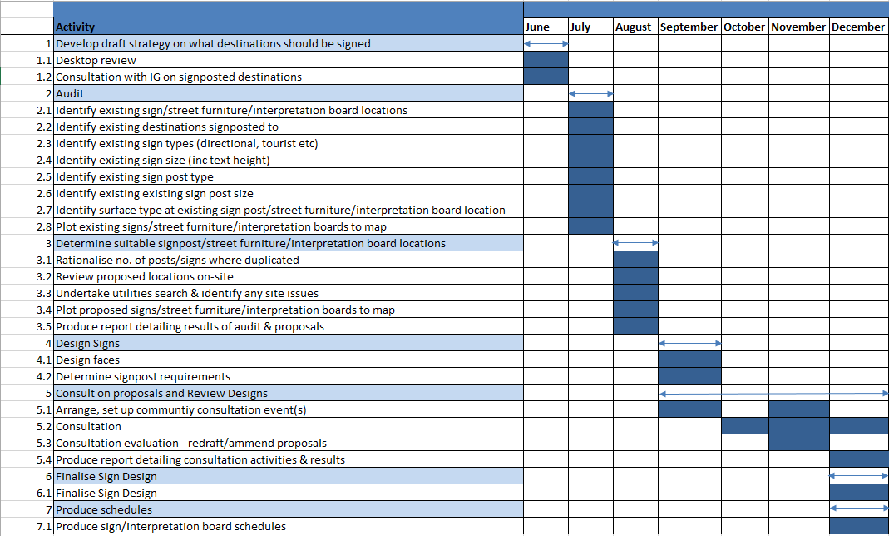

APPENDICES

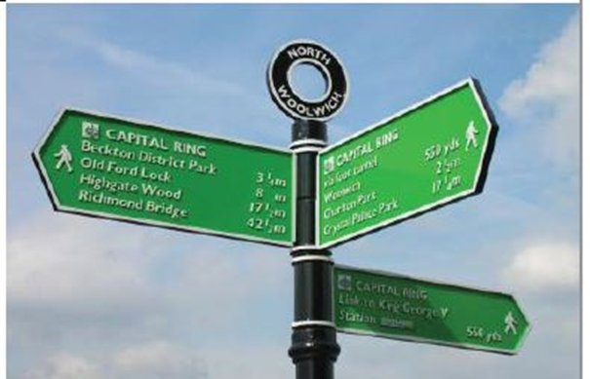
APPENDIX 1: RECOMMENDATIONS

Proposed Finger Posts Signs (See Drawing AC/BSP/208)

It is recommended that a series of new signposts/finger-posts be installed to provide pedestrians and cyclists direction to the (1) Deeside Way, (2) Falls of Feugh, (3) Scolty Hill and the (4) River Dee and (5) Royal Deeside Railway. Pedestrian and cyclist signage will complement the map information contained in orientation panels. NB. Final design and locations will be subject to appropriate planning conditions. Distance information is particularly useful for those travelling by foot or by bicycle and is not currently on existing signage. It is recommended that this information be included on new sign plates. Below are examples of where colour has been used to create a bespoke finish in other UK towns.
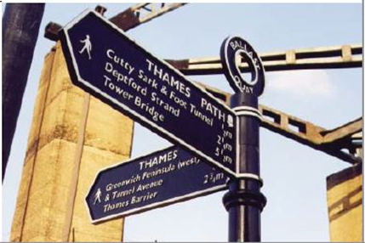
The existing finger posts are black cast-iron with gold lettering and details. They are in reasonable condition and it is recommended that they be retained and be repainted/ re-fitted with new arms where necessary. Consideration will be given to the size of the text to ensure that it is easily legible. The proposed colour combination options are listed below and shown in the diagrams below (NB. the Sapphire colour proposed represents a colour from the Banchory palette).

• Sapphire with Gold text and details.
• Sapphire with White text and details.
• Black with Gold text and details.
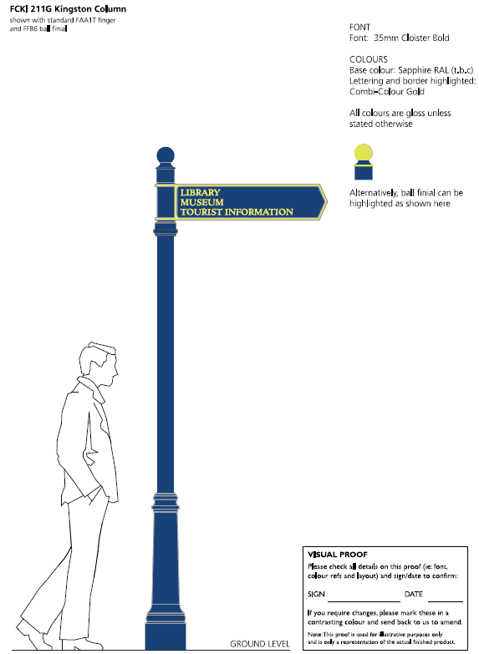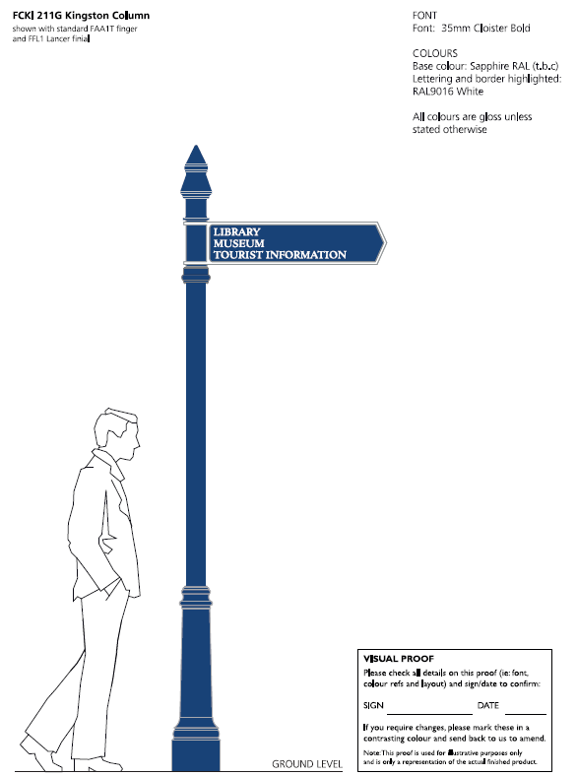
Option 1: Sapphire with Gold details.
Option 2: Sapphire with White details.
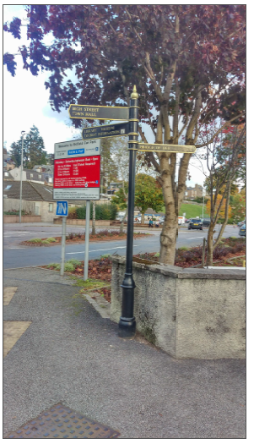
Option 3: Retain Black with Gold details.

 | Location | Arms Present | Arms Pointing | Comment | Arms Proposed | Arms Pointing | ACTION
1 | HIGH STREET, outside the Cancer Research shop | - LIBRARY, MUSEUM, TOURIST INFORMATION  - TOWN HALL, PUBLIC TOILETS  - SCOTT SKINNER SQUARE | - SOUTH  - WEST  - EAST (Tampered with). | Replace existing finger post arm directing people to Town Hall public toilets with sign directing to Bellfield Public Toilets due to opening hours of Town Hall. | - TOWN HALL  - LIBRARY, MUSEUM, TOURIST INFORMATION (i)  - PARKS, TOILETS | - WEST  - SOUTH  - EAST | NEW ARMS
2 | DEE STREET, Outside Bellfield Car Park | - HIGH STREET, TOWN HALL  - LIBRARY, MUSEUM, TOURIST INFORMATION  - BRIDGE OF DEE | - NORTH  - NORTH  - SOUTH | Finger post is to move location to other side of entrance to car park. | - RIVER DEE, FALLS OF FEUGH ½ mile, SCOLTY HILL 2 miles,  - DEESIDE WAY  - SCOTT SKINNER SQUARE VIA SMIDDY WYND, LIBRARY, MUSEUM, TOURIST INFORMATION (i)  - TOWN CENTRE  - TOILETS | - SOUTH  - SOUTH  - NORTH-WEST  - NORTH  - EAST | NEW ARMS,  RE-LOCATE FINGER  POST
3 | BRIDGE STREET, Outside Museum. | - LIBRARY  - SCOTT SKINNER SQUARE  3. BELLFIELD CAR PARK, PUBLIC TOILETS | - NORTH  - NORTH  - EAST |  | - TOWN CENTRE, SCOTT SKINNER SQUARE, SHOPS  - LIBRARY, MUSEUM, TOURIST INFORMATION (i)  - PARKS, TOILETS, DEESIDE WAY | - NORTH  - NORTH  - EAST | NEW ARMS
4 | SCOTT SKINNER SQUARE | - HIGH STREET, TOWN HALL.  - MUSEUM, TOURIST INFORMATION (i).  - BELLFIELD CAR PARK, PUBLIC TOILETS. | - NORTH  - SOUTH  - EAST | Add Bellfield Park, Car park and Public Toilets | - HIGH STREET, TOWN HALL  - LIBRARY, MUSEUM, TOURIST INFORMATION (i)  - PARKS, TOILETS | - NORTH  - SOUTH  - SOUTH-EAST | NEW ARMS  RE-LOCATE FINGER POST
5 | DEE STREET at junction of BRIDGE STREET | N/A | N/A | Provide direction from those parking in Bridge Street Car Park and following Bridge Street finger post | - TOWN CENTRE  - LIBRARY, MUSEUM, TOURIST INFORMATION (i).  - PARKS, DEESIDE WAY  - TOILETS | 1. NORTH  2. NORTH-WEST  3. SOUTH-EAST  4. NORTH -EAST | NEW FINGER POST
6 | HIGH STREET at junction of DEE STREET | N/A | N/A | Provide pedestrian and cycle direction from High Street following High Street finger post. | - FALLS OF FEUGH 3/4 mile,  SCOLTY HILL 2 miles  - LIBRARY, MUSEUM, TOURIST INFORMATION (i), TOWN HALL.  - DEESIDE WAY, RIVER DEE, TOILETS, PARKS. | - SOUTH  - WEST  - SOUTH | NEW FINGER POST
7 | DEE STREET, opposite of King George V park. | N/A | N/A | Provide signage for those entering Banchory from Deeside Way. | - TOILETS, TOWN CENTRE, TOURIST INFORMATION (i) CYCLE PARKING.  - RIVER DEE, FALLS OF FEUGH ½ mile, SCOLTY HILL 2 miles  - ROYAL DEESIDE RAILWAY VIA DEESIDE WAY 3 miles | - NORTH  - SOUTH  - EAST | NEW FINGER POST
8  &9 | RIVERSIDE WALK | N/A | N/A | Waymarking post signposting people at either end of Riverside Walk to the Platties. | RIVERSIDE WALK “PLATTIES” | N/A | NEW WAY-MARKING POSTS

Consideration has been given to locating a finger post on Dee Street by the Bridge directing walkers to the footpath along the edge of the Golf Course. The Golf Course are not keen for this to be located here. However, the adjacent Interpretation Board will direct walkers to this route.
In addition to the recommendations above, consideration should be given to locating one new wooden waymarking post off the Deeside Way to the Kirkyard and associated heritage features. Design should fit with Deeside Way signage, e.g. Wooden waymarking posts. Liaison is required with the Access Officer.

1.2 Proposed Vehicular Signs (See Drawing Number AC/BSP/023)

 | Location | Signs present |  | Comment | Signs Proposed |  | Facing
1 | INCHMARLO ROAD | 30 speed limit roundel,  Welcome to BANCHORY.  Please Drive Carefully  NATIONAL Speed Limit Roundels  (Signs at either side of the road). |  | Regulatory requirement | 30mph Speed Limit Roundel |  | WEST
 |  |  |  |  | NATIONAL Speed Limit Roundel |  | EAST
2 | INCHMARLO ROAD  West entrance into Banchory (A93) |  |  | Replace old boundary sign with new speed limit signs.  Install additional new sign depicting image relevant to Banchory’s heritage.  Use Banchory town slogan “The place to be”. Potentially utilise background colour from Banchory palette. | IMAGE  “Welcome to BANCHORY  The place to be” |  | WEST
3 | RAEMOIR ROAD  Beside entrance to Raemoir Garden Centre.  North entrance into Banchory (A980). | 30 speed limit roundel +  Welcome to BANCHORY.  Please Drive Carefully  40 Speed Limit Roundels  (Boundary sign on WEST side of the road). |  | Regulatory requirement  Replace old boundary sign with new speed limit signs.  Install additional new sign depicting image relevant to Banchory’s heritage.  Use Banchory town slogan “The place to be”. Potentially utilise background colour from Banchory palette. | 30 speed limit roundel |  | NORTH
 |  |  |  |  | 40 speed limit roundel |  | SOUTH
4 |  |  |  |  | IMAGE  “Welcome to BANCHORY  The place to be.” |  | NORTH
5 | RAEMOIR ROAD  (Southbound) | Aberdeen A93 |  | Sign is very old and faded.  Show that parking is available in Town Centre.  Show direction for Crathes Castle. | Aberdeen A93  Heritage Trail  Crathes Castle |  | NORTH
 |  | Braemar A93
 |  | Victoria Heritage Trail | Town Centre |  | Braemar A93  Town Centre  Car Parks
6 | STATION ROAD  Adjacent to junction at foot of RAEMOIR ROAD  (Eastbound) | Raemoir Trout Fishery |  | Add Cowshed Restaurant  Signs to be uniform size to give neat appearance. | Banchory Academy,  Sports Centre,  Tillybrake Ind. Est.  Heritage Trail |  | WEST
 |  |  |  |  | Raemoir Garden Centre and Café
 |  | Raemoir House |  |  | Cowshed Restaurant
 |  | Banchory Academy,  Sports Centre,  Tillybrake Ind. Est.,  Heritage Trail |  |  | Raemoir Trout Fishery
 |  | Raemoir Garden Centre and Café |  |  | Raemoir House
7 | STATION ROAD  Adjacent to junction at foot of RAEMOIR ROAD  (Westbound) | Raemoir Trout Fishery |  | Add Raemoir Trout Fishery sign.  Add Cowshed Restaurant  Signs to be uniform size to give neat appearance. | Banchory Academy,  Sports Centre,  Tillybrake Ind. Est.  Heritage Trail |  | EAST
 |  |  |  |  | Raemoir Garden Centre and Café
 |  | Raemoir House |  |  | Cow Shed Restaurant
 |  | Banchory Academy,  Sports Centre,  Tillybrake Ind. Est.,  Heritage Trail |  |  | Raemoir Trout Fishery
 |  | Raemoir Garden Centre and Café |  |  | Raemoir House
8 | STATION ROAD, adjacent to junction at foot of Raemoir Road | N/A |  | Reinstate directional Aberdeen, Braemar A93 signs which existed before to follow up Advanced Direction Sign. | Aberdeen A93, Braemar A93 |  | NORTH
9 | HILL OF BANCHORY EAST at Woodend Barn | Hill of Banchory Business Park  Town centre  A93 Aberdeen |  | Add direction to Car Parks in Town. | Hill of Banchory  Business Park |  | NORTH
Town centre
Car parks
A93 Aberdeen
10 | HILL OF BANCHORY EAST at Tesco  (Southbound) | Town centre  Aberdeen A93 |  | Provide direction to Car parks. | A93 Aberdeen  Town centre  Car parks |  | NORTH
11 | A93, WEST of Olympia Gardens.  East entrance into Banchory (A93) | See below. |  | Replace old boundary sign with new speed limit signs.  Install additional new sign depicting image relevant to Banchory’s heritage.  Use Banchory town slogan “The place to be”. Potentially utilise background colour from Banchory palette. | IMAGE  “Welcome to BANCHORY  The place to be” |  | EAST
12 | A93, EAST of Olympia Gardens  East entrance into Banchory (A93) | 30 speed limit roundels,  Welcome to BANCHORY.  Please Drive Carefully  40speed limit roundels  (Signs at either side of the road). |  | Regulatory Requirement  Replace old boundary sign with new speed limit signs.  Install additional new sign depicting image relevant to Banchory’s heritage.  Use Banchory town slogan “The place to be”. Potentially utilise background colour from Banchory palette. | 30 speed limit roundel |  | EAST
 |  |  |  |  | 40 speed limit roundel |  | WEST
13 | A93 at HILL OF BANCHORY EAST | Aberdeen A93, Town Centre |  | Provide direction to Car parks. | Aberdeen A93 | Town Centre, Car parks | NORTH
14 | HIGH STREET  West of War memorial. | N/A |  | Advanced direction sign for multiple parking options. | - Bellfield Car Park (w spaces), Coach + WC + Information (i).  - Bridge Street Car Park (w spaces). |  | WEST
15 | HIGH STREET at KINNESKIE ROAD | N/A |  | Direction Sign following advanced direction sign. | Bridge Street Car Park (w spaces). |  | WEST
 |  |  |  |  | Banchory Golf Club
16 | HIGH STREET at KINNESKIE ROAD | N/A |  | Direction Sign following advanced direction sign. | Bridge Street Car Park (w spaces). |  | EAST
 |  |  |  |  | Banchory Golf Club
17 | HIGH STREET approaching Dee Street junction  Eastbound | Peterculter  Kirkton of Durris, Fettercairn |  | Move Falls of Feugh sign to junction  Remove Kirkton of Durris  Signpost Parks & Recreation Ground. | Peterculter,  Bellfield Car Park (w spaces + Coach + WC + information),  Parks  Recreation Ground  Strachan  Fettercairn |  | WEST
 |  |  |  |  | Falls of Feugh Restaurant & Tearoom
 |  | Falls of Feugh Restaurant & Tearoom ¾ ml |  |  | Banchory Lodge Hotel
18 | Junction of  HIGH STREET & DEE STREET  (Eastbound) | Feughside Inn |  | Remove sign for Feughside Inn, as destination is 5 miles from sign location. This exceeds distance suggested in best practice guidance.  Remove Caravan park sign, as only sites that have a minimum of 20 overnight pitches for casual use, are eligible for sign. | Bellfield Car Park (w spaces, Coach, WC & information).  Recreation Ground  Parks  Strachan  Fettercairn |  | WEST
 |  | Caravan Park |  |  | Banchory Lodge Hotel
 |  | Parking in 100 yards |  |  | Falls of Feugh Restaurant & Tearoom
19 | Junction of  High Street & Dee Street  (Westbound) | Feughside Inn |  | Information at proposed Orientation Board in Bellfield Car Park to be signposted.  Remove sign for Feughside Inn, as destination is 5 miles from sign location. This exceeds distance suggested in best practice guidance.  Signpost Parks & Recreation Ground.  Vehicle traffic now directed to main car park(s) for access to TOURIST INFORMATION | Bellfield Car Park (w spaces, Coach, WC & information).  Recreation Ground  Parks  Strachan  Fettercairn |  | EAST
 |  | Tourist Information (i)
 |  | Parking in 100 yards |  |  | Banchory Lodge Hotel
 |  | Falls of Feugh Restaurant & Tearoom |  |  | Falls of Feugh Restaurant & Tearoom
20 | HIGH STREET at Bus Stop EAST of Dee Street  (Westbound) | Aboyne |  | Remove Kirkton of Durris  Give information for spaces in Car Parks  Direct visitors to Information. | Bridge Street Car Park w spaces, Aboyne |  | EAST
 |  | Strachan, Kirkton of Durris |  |  | Bellfield Car Park w spaces, Coach, WC.,  Parks  Recreation Ground  Strachan  Fettercairn
21 | KINNESKIE ROAD | One Way arrow |  | Existing Signs Damaged (Regulatory requirement) | One way traffic arrow
22 | KINNESKIE ROAD | One Way arrow |  | Existing Signs Damaged (Regulatory requirement) | One way traffic arrow
23 | DEE STREET  Across from King George V park. | N/A  N/A |  | Direct people to parks. | King George V Park  Bellfield Park |  | SOUTH
24 |  |  |  |  | King George V Park  Bellfield Park |  | NORTH
25 | DEE STREET, Outside BELLFIELD CAR PARK, | N/A |  | Direct people to information, public toilets. | Bellfield Car Park with spaces, Coach, WC, information. |  | NORTH
26 |  |  |  |  | Bellfield Car Park with spaces, Coach, WC, information. |  | SOUTH
27 | SHAW’S COURT, Scott Skinner Square | NO DOGS FOULING PERMITTED  Access to Bridge Street Shops |  | Recommendation to include a street name sign for SHAW’S COURT or LEADING TO SHAW’S COURT as there is only signage from BRIDGE STREET at present. Have received complaints from residents over the years re lack of signage. | SHAW’S COURT  or  LEADING TO SHAW’S COURT |  | NORTH
28 | VARIOUS | 45 Minute Parking Signs |  | 45 minute parking bay signs are regulatory requirement.  Removal of ‘At any time’ waiting restriction text and consolidation of signs to ensure all are correct | 45 Minute Parking Signs |  | VARIOUS

Vehicular Signs to be Removed (See Drawing Number AC/BSP/006)

 | Location | Signs present | Comment | Signs Proposed | facing | ACTION
3 | HIGH STREET at junction with Kinneskie Road. | Tourist Information | Vehicle traffic now directed to main car park(s) for access to TOURIST INFORMATION | N/A | EAST | REMOVE
4 |  | Tourist Information |  |  | WEST | REMOVE
7 | MOUNT STREET off high Street | Banchory Advice Centre | Remove this sign as the Advice Centre is no longer on Mount Street. | N/A | EAST | REMOVE
12 | SCOTT SKINNER SQUARE | NO SKATEBOARDING  NO CYCLING  NO BALL GAMES | Sign unnecessary and detracts from visual amenity and sense of place. | N/A | SOUTH | REMOVE
21 | DEE STREET, North of Bridge Street | No Right turn | Remove No Right Turn sign.  NO ENTRY signs already communicate this. | N/A | NORTH | REMOVE
23 | SCOTT SKINNER SQUARE outside the Library. | Information (i) Museum | Remove the sign outside the library. Tourist information is currently provided inside the Library with access to the Museum to follow in the future. | N/A | N/A | REMOVE
34 | DEE STREET, South of Bridge Street | No Left turn | Remove No Left Turn sign.  NO ENTRY signs already communicate this. | N/A | SOUTH | REMOVE
36, 37 | Bridge Street next to Scott Skinner Square. | Tourist information. | Vehicle traffic now directed to main car park(s) for access to TOURIST INFORMATION | N/A | EAST & WEST | REMOVE
49 | Bridge Street, Outside Bridge Street Car Park | Tourist Information | Vehicle traffic now directed to main car park(s) for access to TOURIST INFORMATION | N/A | NORTH | REMOVE
53 | HIGH STREET, KINNESKIE ROAD | Golf Club sign on Town Hall building | Proposed brown tourist ‘Golf Course’ signs at junction negate this sign | N/A |  | REMOVE

1.4 Vehicular Signs to be Retained (See Drawing Number AC/BSP/006)

No. | Location | Signs present | Comment | FACING | ACTION
1 | HIGH STREET, entrance to the Square Car Park | IN | Required for flow of vehicles in car park. | NORTH | RETAIN
5 | HIGH STREET, Outside Clydesdale Bank | Royal British Legion 500 yds | Important destination. Potentially visited by non-local members of Armed Forces | EAST | RETAIN
6 | HIGH STREET, Outside Clydesdale Bank | Royal British Legion 500 yds | Important destination. Potentially visited by non-local members of Armed Forces | WEST | RETAIN
8 | HIGH STREET at Watson Lane | No through road. | Traffic Management | SOUTH | RETAIN
9 | SCOTT SKINNER SQUARE | Restricted Parking Zone | Regulatory | NORTH | RETAIN
16 | HIGH STREET | Humps for 450 yds | Regulatory |  | RETAIN
17 | HIGH ST, West of Dee Street | Braemar A93, Fettercairn B974 | Long Distance Navigation Aid | EAST | RETAIN
18 | DEE STREET, South of High Street | Aberdeen A93, Braemar A93 | Long Distance Navigation Aid | SOUTH | RETAIN
19 | SCOTT SKINNER SQUARE | Access ramp to lower level and Bridge Street Shops | Accessibility and direction | NORTH | CLEAN, RETAIN
20 | SCOTT SKINNER SQUARE | Access to ramp to upper level | Accessibility | SOUTH | RETAIN
22 | SCOTT SKINNER SQUARE | Access to lower level shops | Accessibility | NORTH | RETAIN
28 | DEE STREET, opposite Recreation Ground | B974  Strachan,  (Kirkton of Durris), Fettercairn | Long Distance Navigation Aid | NORTH | RETAIN
29 | DEE STREET, at King George V Park entrance | King George V Pavillion | To identify entrance to park | NORTH WEST | RETAIN
35 | BRIDGE STREET, across from Museum. | One Way Arrow | Regulatory | NORTH | RETAIN
38 | SCOTT SKINNER SQUARE CAR PARK | Welcome to Scott Skinner Square Park | Notify drivers that they are agreeing to terms of parking. | EAST | RETAIN
39 | SCOTT SKINNER SQUARE CAR PARK | Welcome to Scott Skinner Square Park | Notify drivers that they are agreeing to terms of parking. | WEST | RETAIN
41 | BRIDGE STREET, entrance to SCOTT SKINNER SQUARE CAR PARK | Pay & Display | Sign drivers to Pay & Display machine. | SOUTH WEST | RETAIN
42 | SCOTT SKINNER SQUARE CAR PARK | DOG OWNERS PICK UP OR PAY UP | Fine Warning | SOUTH WEST | RETAIN
43 | SCOTT SKINNER SQUARE CAR PARK | Welcome to Scott Skinner Square Park | Notify drivers that they are agreeing to terms of parking. | SOUTH WEST | RETAIN
46 | BRIDGE STREET | Dog Litter Sign: SCOOP THE POOP. YOU MAY BE FINED IF YOU DON’T. | Fine Warning | NORTH | RETAIN
47 | BRIDGE STREET, next to Car Park and Golf Course. | CAUTION Beware of Golf Balls | Warning Sign | NORTH | RETAIN
51 | KINNESKIE ROAD (facing into KINNESKIE LANE) | One Way Arrow | Regulatory | WEST | RETAIN
56 | The Square Car Park, HIGH STREET | THE SQUARE CAR PARK FREE PARKING | Required to convey terms of parking. | NORTH | RETAIN

1.5 General Signage Recommendations

Changes to the Traffic Signs Regulations and General Directions (TSRGD) mean the ‘No waiting at any time’ sign plate is no longer required to be installed where double yellow line road markings are in place. Currently in Banchory, legacy sign plates remain in place at these locations. To reduce the need for unnecessary sign clutter, it is recommended that all such signs be removed.
Gateway signs are currently in place on the North, West and East entrances to Banchory (see Drawing Number AC/BSP/006, signs 62, 66/67 and 68/69). Whilst functional, their design makes them visually intrusive.
Recent changes to the regulations governing the use of boundary signs, means it is now possible to incorporate photographic or other images showing an item of local interest as shown in the below example.
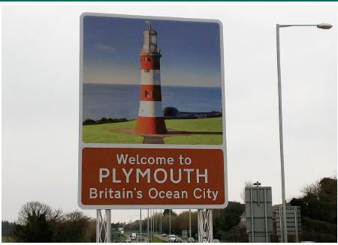
It is recommended that existing gateway signs be replaced with bespoke boundary signs which incorporate imagery associated with Banchory to foster a greater sense of place. It is further recommended that new boundary signage should draw on the Banchory history and branding with the text below the chosen imagery to read “Welcome to BANCHORY, The Place to be”.
It is noted that the font type and size must comply with road signing regulations therefore the accompanying Banchory font cannot be used. Suggested imagery for use on these signs would be one of the following and the image to be used would be commissioned from an artist; this image will be an original image, not a photograph.
- Lavender field
- The Falls of Feugh with leaping salmon
- The Banchory Logo (using only the image of St Ternan, NOT the text).
- Scolty Tower.
Consideration could be given to using the same image at each boundary sign location, or different images at each.

Scott Skinner Square Street Name Plates and Archway Sign (See Drawing Number AC/BSP/041)
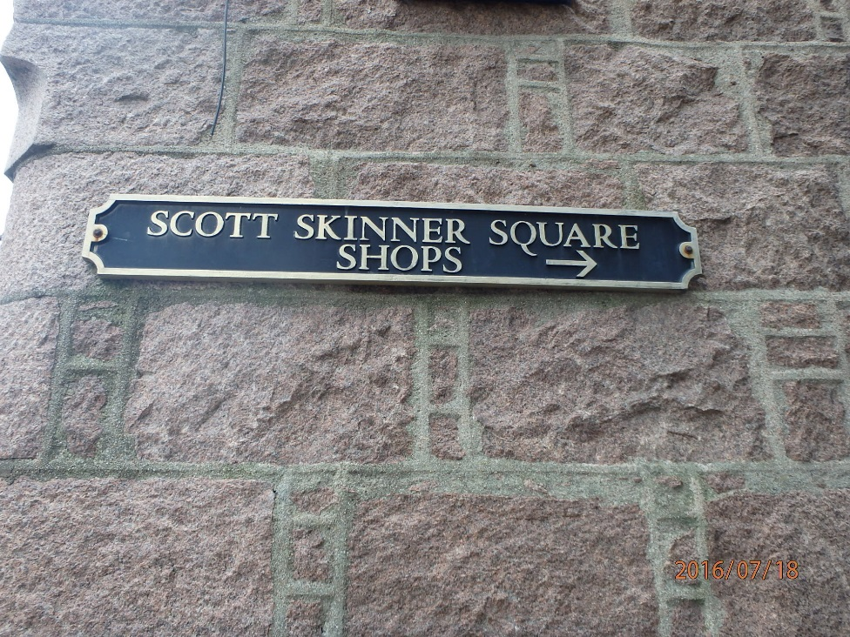
The street name plates around Scott Skinner Square; Smiddy Wynd, Postie’s Walk are largely cast-iron, with a black background and gold lettering to match the Scott Skinner Square archway sign and the finger posts. They are of high quality but many are in need of repainting.
Historically, vehicle access requirements and building ownership issues have presented a challenge when potential improvements to the signing of Scott Skinner Square from its High Street entrance have been considered. There remains however a desire to highlight the location of Scott Skinner Square to passers-by. In addition to the above, space constraints on the footway on High Street further limit options.
Recommendations detailed within this report however include new orientation boards and walking/cycling signage that indicate the location of Scott Skinner Square. The recommended finger post style, of which one will be located at the entrance to Scott Skinner Square, is designed to be more visible to pedestrians/cyclists.
It is therefore recommended that at the entrance to Scott Skinner Square itself, the existing archway signage be retained with two options being presented below, one of which incorporates colours from the Banchory palette.
Repainting options for the archway sign at the entrance to Scott Skinner Square from High Street.
- Option 1: Sapphire background with gold (Sapphire 100, 75, 0, 35 (CMYK) 0, 55, 120 (RGB)) Sapphire from Banchory palette: http://www.visitbanchory.com/community/banchory-brand/
- Option 2: Black background with gold.

Repainting options for the cast-iron street name plates around Scott Skinner Square, Smiddy Wynd, and Postie’s Walk etc.
- Option 1: Sapphire background with gold (Sapphire 100, 75, 0, 35 (CMYK) 0, 55, 120 (RGB)) Sapphire from Banchory palette: http://www.visitbanchory.com/community/banchory-brand/
- Option 2: Sapphire background with white
- Option 3: Black background with gold.

Other
It has been identified that the Scott Skinner memorial plaque on the side of the flower bed on High Street, opposite Dee Street, is in need of cleaning, it is therefore recommended that this be done.

1.6 Information & Interpretation Board Recommendations (See Drawing Number AC/BSP/003B)

Ref no. | Location | Type of board | Existing content | Comments | ACTION
1 | TOWN HALL | Community Noticeboard | Community noticeboard | Board location prone to condensation & little used | REMOVE
2 | HIGH STREET in flower bed. | Community Noticeboard | Community noticeboard | Managed by Community Council | BEING REPLACED BY COMMUNITY COUNCIL
3 | East end of HIGH STREET | Community Noticeboard | Community noticeboard | Owned by Shopkeeper | n/a
4 | DEE STREET at Bowling Club. | Community noticeboard | Community noticeboard | Owned by Recreation Ground | n/a
5 | TERNAN KIRKYARD | Noticeboard | Graveyard notices |  | n/a

Ref no. | Location | Type of board | Board content | Comments | ACTION
6 | BELLFIELD CAR PARK | Information board | WELCOME TO BANCHORY | Recommend that board is removed. Further recommended that content is refreshed and incorporated on the proposed multi sided board (see no. 12 below). | REMOVE
7 | ST TERNAN KIRKYARD | Interpretation board | History of the Ternan Kirkyard and watchtower. | Replace angled board to make legible and fit with new design. Reuse existing metal mounting. | REPLACE
8 | BELLFIELD CAR PARK | Information Board | Town Map & Business Directory | Out of date local business information.  The owners of these boards have authorised and consented to their removal. | REMOVE
9 | RIVER OBSERVATION POINT, DEE STREET | Interpretation Board |  | Remove existing board and incorporate with content of no. 10 onto new single, waist height, angled board on plinth. Reuse existing mounting. | REMOVE
10 | RIVER OBSERVATION POINT, DEE STREET | Orientation and Interpretation boards | “History and wildlife of Banchory riverbank” and “Discover Banchory on Foot”. | Board to be replaced, so that it is consistent with the other refreshed and new interpretation boards. A map of Banchory with a “YOU ARE HERE” marker (plus details of riverside walks) surrounded by border of additional information about natural history and river.  Suggest single waist height angled board on plinth to replace two existing metal framed boards. Existing angled mounting for one could be used. | REPLACE
11 | RIVER OBSERVATION POINT, DEE STREET | Interpretation Board | Pearls in Peril | Panel being installed by Rivers and Fisheries Trust | FORTHCOMING
12 | BELLFIELD CAR PARK | Multi-sided upright boards.  To include:  - 1 x Orientation board  - 1 x Interpretation board  - 1 x Lockable Community noticeboard | - A map of Banchory with a “YOU ARE HERE” marker. Local services and attractions in and around the town will also be marked.  - Information panel with history/heritage and cultural information about Banchory  - Lockable community noticeboard – to be managed by BDI  - Slots for leaflets below community noticeboard section – walks etc | Suggest large multi-sided upright structure with roof – main information feature in the town.  Proposed Locations  Option 1: On the pavement area near the entrance to Bellfield Car Park and cycle racks  Advantages – Minimal groundworks required for installation, no loss of car parking  Disadvantages – Poor visibility from car park, limited space on pavement  Option 2: Bellfield Car Park adjacent to Pay & Display machine  Advantages – Good visibility from car park  Disadvantages – Requires loss of two parking bays, requires construction of new pavement section  Option 3: Bellfield Car Park in area currently a flower bed in front of Doctor’s Surgery. Would include re-planted landscaping element..  Advantages – Good visibility from car park, potential to include seating area, no loss of car parking, no loss of pavement space  Disadvantages – Extensive works required to dig out existing landscaped area | NEW
13 | Sensory Garden, BELLFIELD CAR PARK | 1 board – Interpretation Board | Information about Dee Lavender – history and photographs – could also include information about the forthcoming Sensory Garden. | Suggest waist height angled board on plinth.  Exact content, location and materials to be used to be discussed with Rose Garden project group. | NEW
14 | BRIDGE STREET CAR PARK | 1 board – Orientation board | A map of Banchory with a “YOU ARE HERE” marker. Local services and attractions in and around the town will also be marked. | Suggest waist height angled board on plinth  Car park is being extended, information needed about final layout to determine exact location for board. | NEW
15 | SCOTT SKINNER SQUARE | 1 board – Interpretation Board | Information about Scott Skinner and about the Scott Skinner Square project. | Board either to be attached to wall – two possible locations identified or double sided board attached to finger post.  - Near entrance to Scott Skinner Square on granite wall (either side of alley is possible)  - On side of 66-68 High Street (clothes shop)  - Back to back boards attached to a finger post near the entrance to the library. | NEW
16 | HIGH STREET | 1 Orientation board plus interpretation | A map of Banchory with a “YOU ARE HERE” marker surrounded by border of additional information about High Street eg. Heritage and old photos. | Suggest waist height angled board on plinth. Possible location near traffic lights on north side of street adjacent to RBS. There is a bench there that could be replaced with the board. | NEW
17 | HIGH STREET | Paper orientation maps in bus stops | A map of Banchory with a “YOU ARE HERE” marker. Local services and attractions in and around the town will also be marked. |  | NEW
18 | Eastbound Bus Stop on HIGH STREET | Electronic Information board | Interpretation and maps | Potential to utilise existing electronic bus departure board to incorporate mapping | NEW
19 | FALLS OF FEUGH CAR PARK | 2 Interpretation boards | Replace existing boards with same content | Existing wooden housing to be reused/refurbished | REPLACE
20 | TOWN HALL | Information Board | Business and Services Guide in and around Banchory | Out of date local business information.  The owners of these boards have authorised and consented to their removal. | REMOVE
21 | SCOTT SKINNER SQUARE, main entrance from HIGH STREET. | Retails signs at either side of the alley. |  | Shop owner to be consulted about location of these signs. | REVIEW LOCATION

NB. Final design and locations will be subject to appropriate planning conditions.

There is the potential opportunity to incorporate orientation functionality utilising the existing electronic information point outside the bus stop on High Street. This would be ideal for those visiting the town via public transport. Consideration is currently being given by Aberdeenshire Council to piloting this technology which would include electronic mapping and interpretation functionality.

1.7 Street Furniture Recommendations (See Drawing No.s AC/BSP/001, 002,004, 005A and 027)

No. | Street Furniture | Location | Comments | STATE
 | Cast Iron Lamp Posts | Town Centre | Victorian style cast iron lamp posts are currently in place within the core Town Centre area.  Out with this core area however, yet within the boundary of the Town Centre as defined by the LDP, there are a number of steel lamp posts that are not in keeping with this design/ model/ aesthetic.  To be reviewed in due course of Street Lighting Maintenance Programme. | TO BE REVIEWED
 | Lamp Posts | Town Centre |  | IMPROVED
 | Bollards | Town Centre | Existing black cast iron bollards should be repainted as necessary. Where in very poor condition, bollards should be removed or replaced. | REPAINT/ REMOVE/ REPLACE
 | Utility Cabinets | Town Centre | It is recommended that existing utility cabinets be repainted black where possible. In addition, it is recommended that utility companies be obliged to install any new/replacement utility cabinets so as to match. | REFURBISH
 | Litter Bins | Town Centre | Existing ‘Banchory’ branded bins are in poor condition eg, rusted. In addition, a number of differently styled bins are currently in situ throughout the town. Waste Services will either refurbish the defective bins (rust treat and repaint in black with gold detail) or replace with black metal ‘heritage’ style bins. | REPLACE OR REFURBISH
 | Planters | Town Hall | The majority of the planters are of a granite/stone material, are in good condition and should be retained. The Town Hall planters are green plastic and cannot be repainted to match the others. It is recommended that the green planters be retained in their current state to further distinguish what is the Civic Building. | RETAIN
 | Bench | Scott Skinner Square | The majority of the benches are in reasonably good condition. They are made of various materials and should be retained.  - Recommendation to replace bench next to library entrance with bench similar in style to current seating installed as part of the Scott Skinner Square project.  - Recommendation to either repaint bench on Dee Bridge in black or leave it the way it is.  - Recommendation for any new benches to be constructed of black recycled plastic as per those on the High Street.  - Potential removal of bench at RBS on High Street to locate information board No.16 | REPLACE  REPAINT OR RETAIN
 | Balustrade | High Street – Steps leading to Watson Street | Balustrade is tired looking and needs refreshed. Recommended that it be re-painted black. | REFURBISH

1.8 Recommendations for Materials

Type | Material | Reason
Bench | Recycled black plastic | Environmentally friendly  Highly durable  Low maintenance  Appearance can remain clean and looks very similar to painted timber
Orientation/Interpretation Boards | Various | Designs/Materials dependent on surrounding area as outlined in table at 1.6 and in drawing AC/BSP/003B
Bins | Repaint green metal bins in Black & Gold  Plastic ‘Heritage’ Bin | In-line with Waste Services programme
Planters | As per existing
Lamp Posts | As per existing
Finger posts | As per existing (colour coated where appropriate) | Reinforce Banchory brand.

1.9 Emerging Technologies

- Advancements in technology have led to the birth of ‘Smart Street Furniture’. This is essentially street furniture that harnesses technology to fulfil an additional role over and above its intended purpose. This project could potentially provide the opportunity for Banchory Town Centre to be amongst the first areas in the UK to employ this emerging technology.
- Consideration could be given to the installation of ‘LightMotion’ street lamp posts with integrated electric vehicle charging and Wi-Fi capabilities. This may be of particular interest in the Scott Skinner area where it has been stated that public Wi-Fi access would potentially be desirable.
- ‘Strawberry Smart Benches’ could be considered as modern seating solutions which incorporate mobile phone charging capabilities and foot traffic counters.

1.10 Rubbing Posts

Nature Sign Design have created several sets of nature trail rubbing posts in both wood and brass. Rubbing posts are generally used along nature trails, and allow visitors to take rubbings at points of interest along the nature trail. Each post is different, and depicts an image associated with the area it is located in.

Rubbing posts can be incorporated into activity sheets or booklets. These encourage visitors to explore the nature trail and interact with each post along the way. They are a great way to keep children engaged on longer nature trails. The posts make the nature trail a game that the children are encouraged to complete by collecting or “rubbing” each post.

Nature Sign Design rubbing posts can be made from a variety of materials, such as pine from sustainable FSC (Forestry Stewardship Certified) sources and brass. Brass rubbing posts are exceptionally hard wearing.

Nature Sign Design can design rubbing posts tailor made for a Banchory heritage trail and make posts from submitted designs. These images could include
- Queen Victoria
- Dee Lavender Fields
- Scott Skinner
- Leaping Salmon at the Falls of Feugh
Potential locations such as Deeside Way near the town, Scott Skinner Square, the Ternan Kirkyard, Falls of Feugh, Scolty Hill.

APPENDIX 2: SUPPLEMENTARY INFORMATION

2.1 Asset Guide

An index of each type of sign, street furniture and information board.

Asset | Asset Type | Description | Example Picture
SIGNS | Directional | Provides information on a destination and which direction said destination is. Occasionally with distance to destination in miles or the road to follow. | 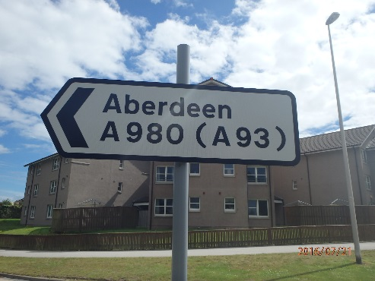
 | Other, Parking Information, Vehicle movement, | Information for vehicle height, car parking information, vehicle/ HGV information. | 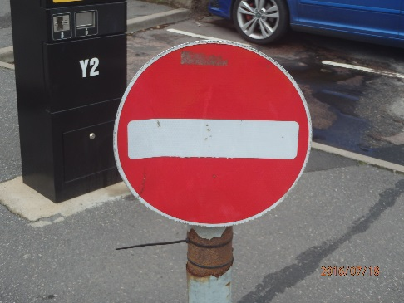
 | Parking | Related to parking of vehicles or information on council car park | 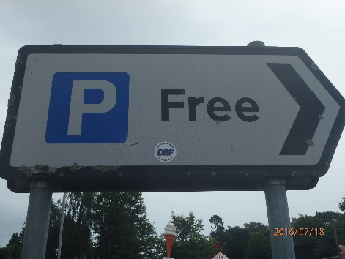
 | Cycling & Walking facilities | Signs for pedestrians and cyclists | 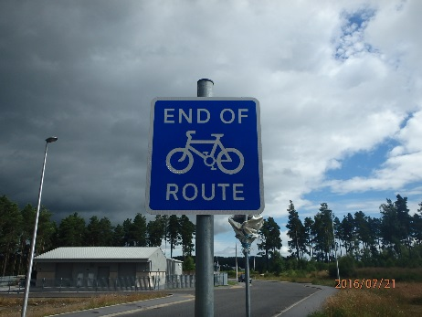
 | Speed Limit | Sign showing maximum speed limit in miles per hour on road. | 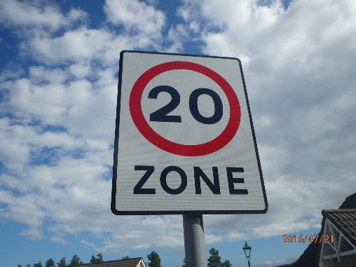
 | Tourist Signs | Brown coloured sign providing direction to tourist destinations. | 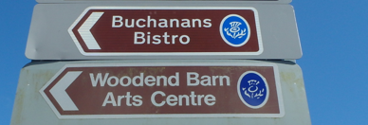
 | Street Name | Displays name of street | 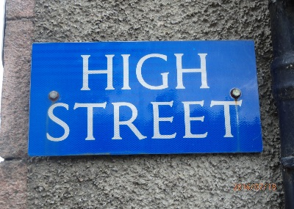
STREET FURNITURE | Planters | Often large containers of soil for plant life; hanging baskets for flowers. | 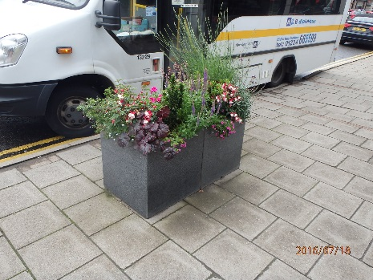
 | Benches | Public seating amenities. | 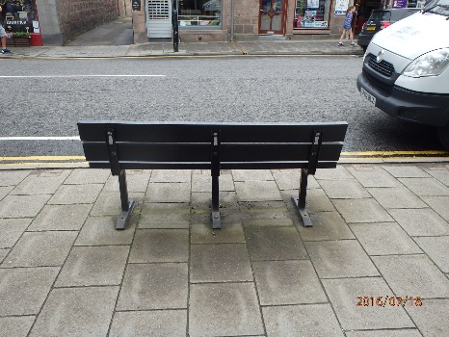
 | Bollards |  | 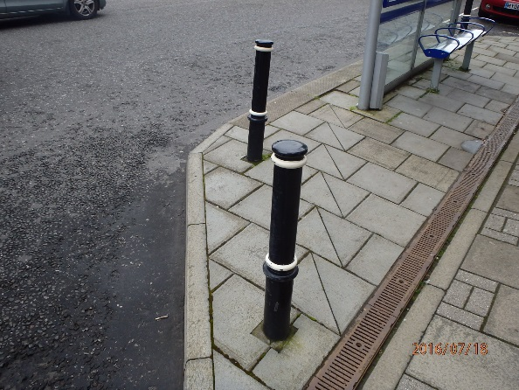
 | Cycle stands | Stands to park and securely lock one’s bicycle. | 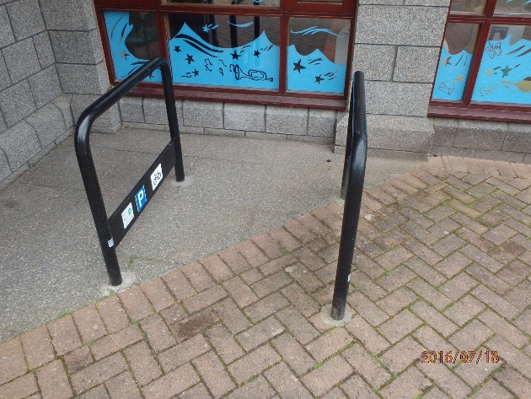
 | Guardrail | Metal railing at pedestrian level | 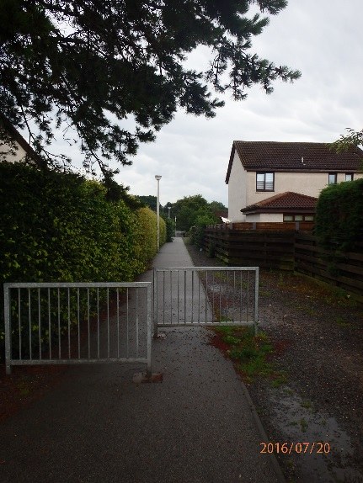
 | A-boards | Boards which advertising for local business displayed on pavements. | 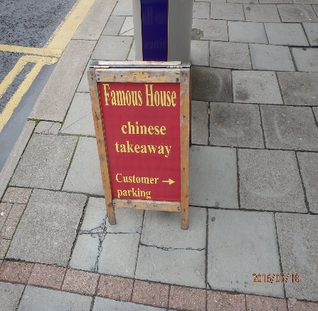
 | Post Boxes | Royal Mail pill boxes for posting letters/ Boxes for Royal Mail staff use. | 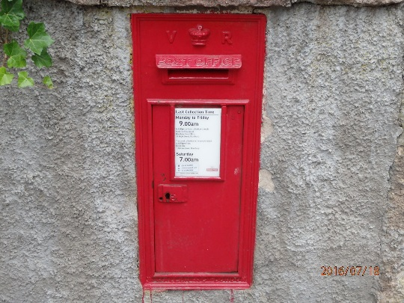
 | Utility Cabinets | Cabinets for electricity, phone lines etc. | 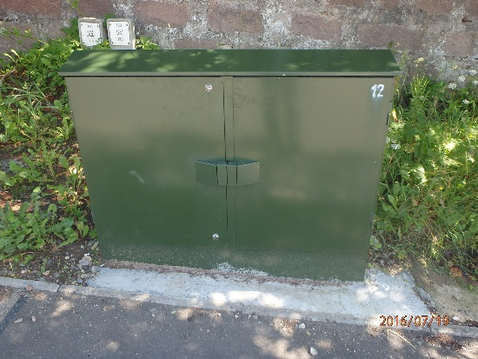
 | Bins | Refuse bins for Litter/ Dog Waste/ Recycling | 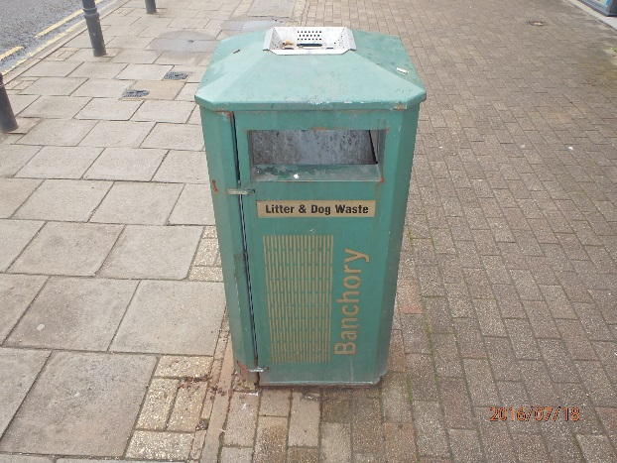
 | Lighting Columns | Lighting columns located in Town Centre Study area –traditional black Victorian design | 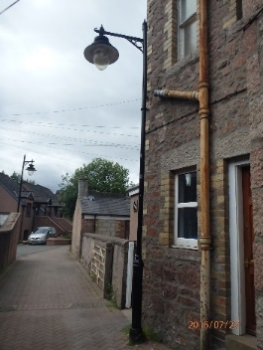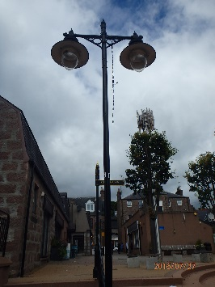
INFO BOARDS | Interpretation  board | Interpretation panels are often used to describe the environment that you are passing through or looking at. Each panel is designed specifically to allow information to be passed on easily to the visitor by using images and text. | 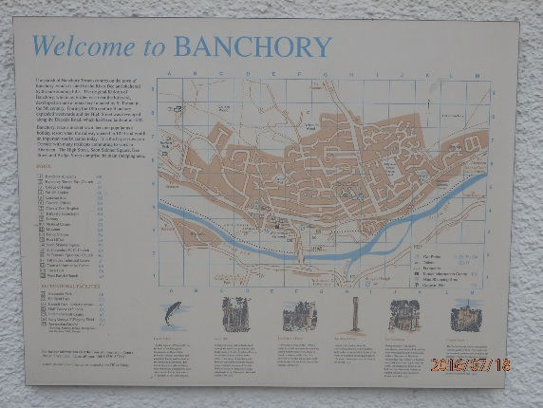
 | Community Noticeboard | Community/group owned and maintained board with general information about town | 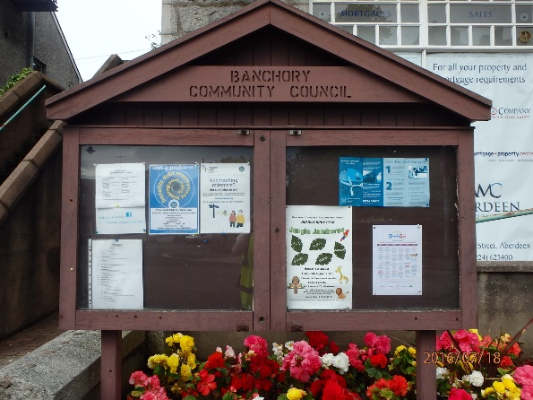

Table of Destinations and Number of Signs, July 2016.

Area | Destination | No. of signs relating to this destination
Town Centre | Banchory Library | 3
 | Banchory Museum | 1
 | Bellfield Car Park | 2
 | British Royal Legion | 3
 | Deeside Indoor Sporting Club | 2
 | Public Toilets - Bellfield Car Park | 2
 | Scott Skinner Square | 8
 | Scott Skinner Square Car Park | 3
 | Tourist Information | 7
 | Town Centre | 4
 | Town Hall | 3
 | Town Hall Car Park | 1
Recommended by Banchory Signage Implementation Group | Milton of Crathes | 1
 | Farmer’s Market (Temporary) | 1
Out with Town Centre | Woodend Barn | 8
 | Aberdeen | 15
 | Aboyne | 3
 | Alford | 5
 | Auchattie | 3
 | Ballater | 2
 | Banchory Academy | 4
 | Banchory Business Park | 3
 | Banchory Christian Fellowship Church | 4
 | Banchory Primary School | 2
 | Banchory Sports Centre & Pool | 4
 | Braemar | 7
 | Bridge of Feugh Car Park | 3
 | Buchanan’s Bistro | 8
 | Cairngorms National Park | 1
 | Crathes Castle | 1
 | Deeside Way | 14
 | Echt | 7
 | Falls of Feugh Restaurant & Tearoom | 6
 | Fettercairn | 4
 | Feughside Inn | 2
 | Fire Station | 4
 | Glassel | 1
 | Glen o' Dee Hospital | 2
 | Golf club | 1
 | Golf course | 3
 | Hill of Banchory Business Park | 5
 | Hill of Banchory Primary School | 3
 | Hill of Banchory School | 1
 | Hirn | 4
 | Household Waste & Recycling Centre - Crow's Nest | 5
 | Inchmarlo Golf Course & Restaurant | 1
 | King George V Park | 1
 | Kirkton of Durris | 6
 | Lumphanan | 1
 | Mill of Cammie | 1
 | Peterculter | 3
 | Public Toilets - Falls of Feugh Car Park | 1
 | Raemoir Garden Centre | 4
 | Raemoir House Hotel | 2
 | Raemoir Trout Fishery | 2
 | Scolty Hill | 3
 | Scolty Woodland Walks | 3
 | Silverbank Roads Depot | 1
 | St Ternan’s Cemetery | 1
 | Strachan | 2
 | Tillybrake Industrial Estate | 4
 | Tilquhillie | 3
 | Torphins | 4
 | Upper Lochton | 2
 | Woodend Barn | 8

Attractions, businesses, organisations without signage at time of data collection, July 2016.

- Aberdeenshire Council Social Care
- Aberdeenshire Council (Building Opposite town Hall)
- Aberdeenshire Council Registrar’s
- Banchory Bowling Club & Recreation Grounds
- Bridge Street Car Park
- Burnett Arms Hotel
- Burnett Car Park
- Codona’s Amusement Park
- Douglas Arms Hotel
- Dr Francis Adam War Memorial
- Falls of Feugh/ Bridge of Feugh
- High Street War Memorial
- Police Station
- Post Office
- Public Toilets @ Town Hall
- River Dee
- The Square Car Park
- The Square War Memorial
- The Stag Hotel
- Bellfield Park
- Royal Deeside Railway
- Banchory Ternan Historic Kirkyard and Cemetery
- Douglas Vault
- Kincardine O’ Neil Village
- Potarch Bridge and Green
- Hill of Fare
- Nine Stanes, Mulloch Wood
- Banchroy Sports Centre
- Banchory Ternan East Church
- Bellfield Park
- Burnett Park
- Hill of Banchory Community Learning & Development
- James Hunter Fountain
- Mercat Cross
- Morrisons/ Petrol Station/ Recycling Point
- Tesco/ Petrol Station / Recycling Point
- Ravenswood Country Club (Royal British Legion)
- Silverbank Caravan Park
- Skate Park
- St Columbas Church
- St Ternan’s Church
- The Watch House ( in Ternan Kirykard)
- Tillybrake Road Playing Field
- Tor-nan-Coille Hotel
- Village Guest House

APPENDIX 3: Drawings

AC/BSP/001 – Lamp post recommendations

AC/BSP/002 – Bins recommendations

AC/BSP/003b – Information board recommendations

AC/BSP/004a – Benches recommendations

AC/BSP/005a – Street furniture recommendations

AC/BSP/006a – Existing signs

AC/BSP/023 – Proposed vehicular signs

AC/BSP/027 – Planters recommendations

AC/BSP/028 – Fingerposts recommendations

AC/BSP/041 – Scott Skinner Archway & Street Name Plates

https://www.naturesigndesign.co.uk/nature-trails/nature-trail-rubbing-posts/

